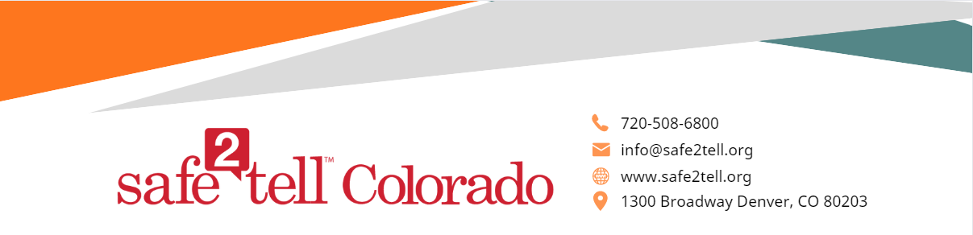

Dear teachers, administrators, and school staff,

In an upcoming presentation, we will discuss Safe2Tell with students. The following is a brief introduction to Safe2Tell and a summary of what students will learn in the presentation. I have also included frequently asked questions and answers for your reference.
What is Safe2Tell?
We founded Safe2Tell on the idea that early intervention is the key to preventing violence and saving lives. Safe2Tell Colorado gives students, parents, and community members a safe, anonymous way to report any threats to their safety or the safety of others. We developed Safe2Tell with the following principles:

- Educate - Encourage - Equip - Empower -

- Safe2Tell wants to educate the community on reporting safety concerns, break the code of silence and provide a trusted way for young people to make reports anonymously about things they may see or hear that cause concern.
- Safe2Tell aims to encourage everyone to play a role in prevention.
- Safe2Tell wants to equip our community with a direct way to report concerns anonymously.
- Safe2Tell empowers those who have the intention to help, prevent, or protect to make a difference.
We know that students often know about mental health or safety concerns about their peers before adults do. We encourage students to be advocates for their community and be part of keeping everyone safe. Safe2Tell always encourages students to talk to a trusted adult first when they have concerns; however, we know it isn't always easy for students to speak up. The creation of Safe2Tell results from these challenges. It is a resource that aims to provide an anonymous way for students to make reports any time, any day. About 98% of reports submitted to Safe2Tell fall into the category of a good faith report and are actionable. False reports make up less than 2% of reports. The Information in a false report lacks evidence of an intent to help, prevent, or protect.

How does Safe2Tell work?
Students make reports by calling 1-877-542-7233, using the free mobile app, or through Safe2Tell.org. Students can make reports any time, any day. The analysts then send the report to local level school personnel and law enforcement teams for investigation. It is important to keep Safe2Tell report recipients updated in our P3 system. There is a form on our website under “Connect With Us” for updating this contact information.
Can teachers report to Safe2Tell?
Yes, adults can report to Safe2Tell. Please be aware that staff should follow district protocols when deciding to report to Safe2Tell. As Safe2Tell is anonymous, Safe2Tell is not the avenue for Mandated Reporters to report concerns that fall under the Mandated Reporter Law.
What should I tell my students about Safe2Tell?
Option 1 is always to talk to a trusted adult when students have concerns or feel unsafe. Safe2Tell always encourages students to name the trusted adults in their lives. However, we know that speaking up can be difficult for students, which is where Safe2Tell comes in as option 2. Students can make reports about things such as bullying, threats, safety concerns, suicide, drugs, etc. We want students to be advocates for their peers and community and speak up when they know about a potentially dangerous situation. It is also important for students to understand that they don’t need to have all the details to make a report. Safe2Tell will work with the school and local law enforcement to learn additional information that is needed.

Important Things to Note:

- Parents can make a report themselves as well as with/on behalf of their child (ren).
- Safe2Tell is the go-between or middleman in order to get information from a reporter to the appropriate local school and law enforcement personnel.
- Safe2Tell does not investigate reports themselves and cannot enforce an outcome.
- Safe2Tell cannot notify the reporting party of the report outcome because of the anonymity of the program. All outcome information is private and autonomous to Safe2Tell.
- We do not include Safe2Tell reports on a child’s academic record. Safe2Tell accepts reports about youth in other states and countries, which are forwarded to the appropriate jurisdiction. (Use Community at Large as the school/location.)

Frequently Asked Questions and suggested responses:
  - Can I report _____________ to Safe2Tell?
    - For reference, the most common reports received, in order, are suicide, bullying, and drugs/vaping.
    - When answering this question, we encourage you to say, “If this is something that makes you feel unsafe, first talk to a trusted adult. If you don’t feel comfortable talking and want to be anonymous, or if it’s after hours, report it to Safe2Tell.” We do not want to limit the things students feel they can report.

  - What happens when I make a Safe2Tell report? Or, what happens if I report _________ to Safe2Tell?
    - The reports go to the same people as if you were to tell a trusted adult. (For example, if your school does Restorative Practices as an intervention for bullying, they may use the same process for a Safe2Tell report.)

  - Is it really anonymous? What if I’m the only one my friend told?
    - Yes, it is really anonymous. However, this may not protect you from the rumor mill of your peers. It may have been another peer, a teacher, a community member, or someone else that made the report.

  - If it’s anonymous, can’t students use it to make things up?
    - Yes. This is important. It’s not OK to make something up.
    - We take your safety seriously. Safe2Tell is anonymous because we want students to feel comfortable making reports about things that are hard to talk about. The goal is to keep everyone safe. Our school, law enforcement, the school district, and mental health agencies are all working together to keep our community safe. Made up reports take valuable resources away from those who really need it.
    - Compare a false report to the story about “The Boy Who Cried Wolf.”
    - Even if the reporter is anonymous, there may be other ways to investigate who made the report.
    - If you hope to:
Protect, prevent, or help, report it!
Hurt, harass, bully, make something up, don’t!
    - It is OK if a report comes back and is just a rumor, a misunderstanding, or unfounded. You don’t need to have all the details to make a report.

  - You overhear students saying, “I’m going to Safe2Tell you…”
    - We recommend a calm redirect for the student by saying, “Let’s remember to only report unsafe behaviors to Safe2Tell. Please set a good example for our classmates and be respectful of those who are actually struggling with serious things and need help. Safe2Tell is about being an advocate for our community and everyone’s safety.”

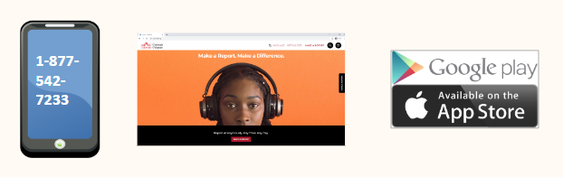
Where can you find Safe2Tell?

- Call us at 877-542-7233. We have an option to select a different language if needed.
- Find us at our website www.safe2tell.org
- Download our free mobile app

